Exercise No:5

Date: 15.10.20

Aim: To print the missing characters to make the string panagram.

Program:

a=input()

a=set(a.strip())

a.remove(chr(32))

b="abcdefghijklmnopqrstuvwxyz"

b=set(b)

b=b.difference(a)

b=list(b)

b.sort()

print("".join(b))

Link:

<http://103.53.53.18/mod/vpl/forms/edit.php?id=235&userid=1702>

Output:

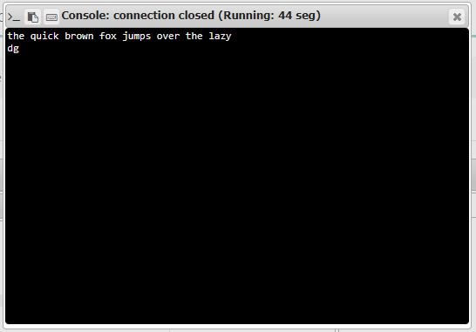

Result:

Thus the program has been successfully executed and the output has been verified.